

SEMESTER TRAINING REPORT

On

“Config Based UI: A React App that Works on Config UI Received from API”

Submitted in partial fulfilment of requirements for the award of the degree

Bachelor of Technology In

Computer Science and Engineering To

IKG Punjab Technical University, Jalandhar

SUBMITTED BY: Name: Sachin Kumar

Roll no.: 1902219 Semester: 8th Batch: 2019-23

Under the guidance of Mr. Rajeev Sharma Assistant Professor

DEPARTMENT OF COMPUTER SCIENCE AND ENGINEERING Chandigarh Engineering College-CGC, Landran Mohali, Punjab - 140307

CERTIFICATE

This is to certify that Mr. Sachin Kumar has partially completed / completed / not completed

the Semester Training during the period from January 2023 to June 2023 in our Organization /

Industry as a Partial Fulfilment of Degree of Bachelor of Technology in Computer Science &

Engineering.

(Signature of Project Supervisor)

Date: 31-05-2023

i



CANDIDATE DECLARATION

I hereby declare that the Project Report entitled ("Config Based UI: A Config Based UI: A React App that Works on Config UI Received from API ") is an authentic record of my own work as requirements of 8th semester academic, during the period from 2nd January 2023 to 30th June 2023 for the award of degree of B. Tech. (Computer Science & Engineering, Chandigarh Engineering College- CGC, Landran, Mohali under the guidance of (Mr. Rajeev Sharma).



(Signature of Student) (Sachin Kumar) (1902219)

Date: 31-05-2023

Certified that the above statement made by the student is correct to the best of our knowledge

and belief.

Signatures

Examined by:

1. 2. 3. 4.

Head of Department (Signature and Seal)

ii

ACKNOWLEDGMENT

I take this opportunity to express my sincere gratitude to the Director- Principal Dr. Rajdeep

Singh Chandigarh Engineering College, Landran for providing this opportunity to carry out the

present work.

I am highly grateful to the Dr. Sukhpreet Kaur HOD CSE, Chandigarh Engineering College,

Landran (Mohali). I would like to express my gratitude to other faculty members of Computer

Science & Engineering department of CEC, Landran for providing academic inputs, guidance &

Encouragement throughout the training period. The help rendered by Mr. Rajeev Sharma;

Supervisor for Experimentation is greatly acknowledged.

iii

ABOUT COMPANY

As a final semester student pursuing a degree in Computer Science & Engineering, I had the

opportunity to gain valuable industry experience through a Six-month Semester Training

program with 42Gears Mobility Systems Private. Ltd.

During my training, I received a training in Swift, which provided me with a strong

foundation in programming and software development. However, my major project was focused

on the use of swift on mobile device management part in device side.

From 42Gears’ founding in 2009 up until today, we find our inspiration in the pursuit of one goal: ` being at the forefront of innovative enterprise mobility solutions. Along the way, we’ve pioneered cloud solutions for enterprise mobility and gained recognition for our unified endpoint management technology. We’ve taken every challenge head-on and can’t wait to see what the future holds for us.

Our team is filled with passionate problem-solvers working to refine and advance our technologies to facilitate the growth of businesses worldwide. We want for businesses (including yours!) to focus on being the best they can be, without limitations, while we support you behind-the-scenes, doing the best we can do. We know the global workplace changes constantly, so our mobility solutions are designed to scale and extend along with your business. Sure MDM is the product on which I am working, is a mobile device management (MDM) solution provided by 42Gears. MDM refers to the administration of mobile devices, such as smartphones, tablets, and rugged devices, used in business environments. SureMDM helps businesses manage and secure their mobile devices, applications, and data.

**Some key features of SureMDM include:**

Device Management.

Application Management

Security and Compliance

Content Management

Location Tracking

Reporting and Analytics

iv

ABSTRACT

The Config-Based User Interface (UI) project aims to develop a flexible and customizable UI framework for software applications. Traditional user interfaces often lack the ability to adapt to diverse user preferences and requirements. By leveraging configuration files, this project introduces a novel approach to UI design that empowers users to personalize their application's appearance and behaviour without modifying the underlying code.

The project begins by developing a UI framework that supports the dynamic loading and parsing of configuration files. These configuration files allow users to specify various aspects of the UI, including colours, fonts, layouts, and functionality. Through a well-defined schema, the system interprets the configuration files and applies the specified settings to the UI components during runtime.

To facilitate the creation and management of configuration files, a user-friendly graphical interface is developed. This interface provides an intuitive way for users to modify the UI settings without requiring programming skills. Users can easily customize the application's look and feel, rearrange components, enable or disable features, and define their own shortcuts or gestures.

The project also focuses on providing extensibility and modularity within the UI framework. Developers can define their own UI components and behaviours as modules that can be loaded and integrated seamlessly into the system. This allows for the creation of specialized UI components tailored to specific use cases, enhancing the overall versatility and adaptability of the application.

Furthermore, the project explores the integration of context-awareness into the UI framework. By leveraging user context information, such as device type, location, or user preferences, the system can dynamically adjust the UI configuration to optimize the user experience. This context-awareness feature enables the UI to adapt intelligently to different environments and user needs.

The Config-Based User Interface project offers significant benefits to both users and developers. Users gain the ability to personalize their application experience, improving usability and satisfaction. Developers benefit from a more modular and flexible UI framework that simplifies customization and reduces the need for extensive UI coding. The project's outcomes have the potential to revolutionize UI design and open new possibilities for tailored user experiences in a wide range of software applications.

v

TABLE OF CONTENTS

CONTENT PAGE NO.

Certificate ......................................................................................................................................i

Candidate Declaration .................................................................................................................ii

Acknowledgement ........................................................................................................................iii

About Company............................................................................................................................ iv

Abstract......................................................................................................................................... v

Table of Contents......................................................................................................................... vi

List of Figures............................................................................................................................viii

CHAPTER 1: INTRODUCTION............................................................................................1 - 10

1.1 BACKGROUND............................................................................................................2

1.2 MOTIVATION.............................................................................................................3

1.3 OBJECTIVE ..................................................................................................................4

1.3 DIFFERENCE BETWEEN CONFIG VS SERVER DRIVEN UI................................6

1.4 FEASIBILITY ANALYSIS ..........................................................................................7

1.4 POTENTIAL RISK.........................................................................................................9

CHAPTER 2: SOFTWARE REQUIREMENTS AND SPECIFICATIONS.......................11 - 16

2.1 ANALYSIS DOCUMENT ...........................................................................................11

2.2 PURPOSE.....................................................................................................................11

2.2 SCOPE...........................................................................................................................11

2.3 LITERATURE SURVEY............................................................................................13

2.5 SPECIFIC REQUIREMENTS.....................................................................................14

CHAPTER 3: INTRODUCTION AND DETAIL OF SOFTWARE USED.......................17 - 22

3.1 EXPRESS………………………………………….....................................................17

3.2 MONGO DB ………………………………………....................................................19

3.3 BUNDLER…………………………………………....................................................22

vi

CHAPTER 4: SYSTEM DESIGN.......................................................................................23 - 26

4.1 OVERVIEW……………...........................................................................................23

4.2 DEMO API………………………………………………..........................................25

CHAPTER 5: SYSTEM IMPLEMENTATION AND TESTING......................................27 - 31

5.1 IMPLEMENTATION..................................................................................................27

5.2 CONFIG API IMPLEMENTATION...........................................................................27

5.3 REACT IMPLEMENTATION...................................................................................29

5.4 SHIMMER IMPLEMENTATION..............................................................................30

CHAPTER 6: IMPLEMENTATION OF THE MODULES...............................................32 - 37

6.1 REACT JS PART …………………………………...................................................32

6.2 API DEVELOPMENT…………................................................................................34

CHAPTER 7: TESTING .....................................................................................................38 - 40

CHAPTER 8: SCREENSHOTS..........................................................................................41 - 45

CHAPTER 9: CONCLUSIONS & FUTURE SCOPE........................................................46 - 48

9.1 CONCLUSION.............................................................................................................46

9.2 FUTURE SCOPE .........................................................................................................47

CHAPTER 10: REFERENCES / BIBLIOGRAPHY.............................................................49-50

vii

LIST OF FIGURES

CONTENT PAGE NO.

Figure 1: User Interface……………………………………………..............................................3

Figure 2: Technologies Used……………………………..............................................................17

Figure 3: Bundler…………............................................................................................................22

Figure 4: Config UI.........................................................................................................................26

Figure 5: File Structure…………………………..........................................................................32

Figure 6: Jest…………………………………………………………………………………. ….38

Figure 7: Shimmer Loading …………………………………………………………..................41

Figure 8: After API Load………………………………………………………….......................42

Figure 9: Contact Page…………... .................................................................................................43

Figure 10: Restaurant Menu.............................................................................................................44

.

Figure 11: Config API ……………………………………….........................................................45

viii

CHAPTER 1: INTRODUCTION

Welcome to the project file for our Config-Based UI Project. In today's fast-paced digital world, user interfaces play a critical role in shaping the user experience of software applications. The ability to configure and customize the UI according to specific requirements and preferences has become increasingly important. To address this need, our project aims to develop a Config-Based UI solution that empowers developers and end-users to create dynamic and flexible user interfaces effortlessly.

This project file will serve as a comprehensive guide to understanding the objectives, methodologies, and outcomes of our Config-Based UI Project. We will delve into the fundamental concepts, design principles, and implementation details that make our solution unique and valuable. Whether you are a developer looking to enhance UI configurability or an end-user seeking a personalized experience, this project file will provide valuable insights and resources.

The primary goal of our project is to create a user-friendly framework that allows developers to design and modify UI elements through a simple and intuitive configuration system. By reducing the reliance on hard-coded UI implementations, our Config-Based UI solution enables quicker iterations, promotes code reusability, and facilitates seamless UI updates. It offers a dynamic environment where changes can be made effortlessly, accommodating evolving user requirements without extensive coding efforts.

In this project file, we will explore the key features and functionalities of our Config-Based UI solution. We will discuss the underlying technologies, frameworks, and tools used to develop the project. Additionally, we will provide step-by-step instructions on how to set up and utilize the Config-Based UI framework effectively. The project file will also include code snippets, demonstrations, and examples to illustrate the practical implementation and benefits of our solution.

We believe that our Config-Based UI Project will significantly contribute to the field of software development, empowering developers to create highly customizable and adaptable user interfaces. By leveraging the power of configuration, our solution eliminates the need for repetitive code changes, reduces development time, and enhances the overall user experience. We are excited to share our findings and insights with you in this project file and hope that it inspires innovation and advancements in UI development.

Thank you for joining us on this journey through our Config-Based UI Project. Let's explore the limitless possibilities of configurable user interfaces together!

1

1.1 BACKGROUND

The field of user interface (UI) development has witnessed significant advancements in recent years, driven by the increasing demand for seamless and user-friendly software applications. One of the emerging trends in UI development is the adoption of a configuration-based approach, which offers numerous advantages over traditional, code-intensive UI development methods.

The Config Based UI Development project aims to explore and leverage the potential of this innovative approach, empowering developers to create flexible and customizable user interfaces more efficiently. By utilizing configuration files, this project aims to reduce development time, enhance maintainability, and provide greater adaptability to meet evolving user requirements.

In the traditional UI development process, developers often have to write extensive code to define various elements, such as layouts, components, and styling. This approach can be time-consuming, error-prone, and challenging to modify, especially when requirements change frequently. Furthermore, it can pose a significant barrier to entry for designers and non-technical stakeholders who lack coding expertise.

The Config Based UI Development project seeks to address these challenges by enabling developers to define UI elements and behaviours through a configuration file. This file serves as a central repository for specifying layouts, components, styles, interactions, and other UI-related aspects. By abstracting the UI definition into a separate configuration layer, developers can decouple UI implementation from the application logic, allowing for greater modularity and reusability.

Through this project, we aim to develop a robust and user-friendly framework that facilitates the creation and management of configuration files for UI development. The framework will provide a set of intuitive tools and utilities for defining UI elements, configuring their properties, and establishing relationships between various components. It will support a wide range of platforms and technologies, ensuring compatibility with popular UI frameworks and libraries.

The Config Based UI Development project will also emphasize the importance of collaboration and iteration in the UI design process. By separating the UI configuration from the application code, designers and non-technical stakeholders can easily participate in the UI design process, providing their inputs and feedback directly in the configuration files. This collaborative approach fosters rapid iteration and empowers stakeholders to make real-time adjustments to the UI without requiring extensive coding or development cycles.

In conclusion, the Config Based UI Development project aims to revolutionize the way user interfaces are developed by leveraging the power of configuration files. By simplifying the UI development process, enhancing flexibility, and promoting collaboration, this project will enable developers to deliver highly adaptable and engaging user experiences while reducing development time and effort.

2



USER INTERFACE

1.2 MOTIVATION

The motivation behind the Config Based UI Development project stems from the growing need for efficient, customizable, and maintainable user interfaces in software applications. Traditional UI development approaches often involve extensive coding, which can be time-consuming, error-prone, and challenging to modify. Additionally, these approaches create barriers for designers and non-technical stakeholders to actively participate in the UI design process.

To address these challenges and capitalize on emerging trends, such as the use of configuration files, the Config Based UI Development project seeks to revolutionize the way user interfaces are developed. By adopting a configuration-based approach, we aim to empower developers, designers, and stakeholders with a more streamlined and collaborative UI development process.

The primary motivation for this project can be summarized as follows:

Efficiency: Config Based UI Development aims to significantly reduce the time and effort required for UI implementation. By abstracting the UI definition into configuration files, developers can leverage pre-defined templates, components, and styles, minimizing the need for extensive coding. This approach not only accelerates the UI development process but also enables faster iterations and shorter time-to-market.

Flexibility and Customization: Config Based UI Development provides unparalleled flexibility and customization options. Developers can easily modify UI elements, layouts,

3

and styles by tweaking the configuration files, without having to delve into the intricacies of the underlying code. This empowers them to create unique and tailored user experiences that align with specific project requirements and user preferences.

Modularity and Reusability: The project emphasizes the principles of modularity and reusability in UI development. By decoupling the UI implementation from the application logic, Config Based UI enables the creation of modular UI components that can be reused across different projects. This not only improves development efficiency but also enhances code maintainability and scalability.

Collaboration and Stakeholder Engagement: Config Based UI Development facilitates active collaboration between developers, designers, and stakeholders. By providing a common configuration layer for UI definition, designers can easily participate in the UI design process, contributing their expertise and insights. Non-technical stakeholders can also provide real-time feedback, ensuring that the UI aligns with their expectations and needs. This collaborative approach fosters a sense of ownership and creates user interfaces that truly reflect the requirements of the end-users.

Future-Proofing: The project acknowledges the dynamic nature of UI requirements and the need for adaptability. By adopting a configuration-based approach, the UI can be easily modified and updated to meet evolving user needs and industry trends. Changes can be made swiftly and efficiently, ensuring that the application remains relevant and competitive in a rapidly changing technological landscape.

In conclusion, the Config Based UI Development project is motivated by the desire to transform UI development practices by leveraging the power of configuration files. By focusing on efficiency, flexibility, collaboration, and future-proofing, this project aims to empower developers and stakeholders to create highly customizable and maintainable user interfaces that deliver exceptional user experiences.

1.3 OBJECTIVE

The objective of the Config Based UI Development project is to leverage the potential of configuration-based approaches in UI development to create efficient, customizable, and maintainable user interfaces. The project aims to provide a comprehensive framework and

4

set of tools that enable developers to utilize configuration files for defining, configuring, and managing UI elements, layouts, styles, and interactions.

The specific objectives of the project are as follows:

Streamline UI Development: The project seeks to simplify and accelerate the UI development process by utilizing configuration files. By providing a unified and intuitive approach to defining UI elements and their properties, developers can focus on the application logic while leveraging pre-built templates, components, and styles from the configuration files. This objective aims to reduce development time and effort, allowing for faster iterations and increased productivity.

Enhance Flexibility and Customization: The project aims to empower developers to create highly customizable and adaptable user interfaces. By leveraging configuration files, developers can easily modify UI elements, layouts, and styles without extensive coding. This objective promotes flexibility, allowing UIs to be tailored to specific project requirements, user preferences, and evolving needs.

Improve Maintainability and Reusability: The project emphasizes the principles of modularity and reusability in UI development. By separating UI implementation from the application logic through configuration files, developers can create modular UI components that are easier to maintain and reuse across different projects. This objective aims to enhance code organization, reduce redundancy, and promote scalability.

Foster Collaboration and Iteration: The project recognizes the importance of collaboration between developers, designers, and stakeholders in the UI design process. By providing a common configuration layer, the project enables active participation from all stakeholders, including non-technical team members. This objective facilitates effective collaboration, promotes iterative design, and ensures that the UI aligns with user expectations and requirements.

Ensure Cross-Platform Compatibility: The project aims to develop a framework that supports a wide range of platforms and technologies. By providing compatibility with popular UI frameworks and libraries, the objective is to ensure that the Config Based UI Development approach can be seamlessly integrated into various software applications. This promotes cross-platform compatibility and ensures that the benefits of configuration-based UI development can be leveraged across different environments.

5

Promote Future-Proofing: The project aims to create UIs that are adaptable to future changes and advancements. By utilizing configuration files, the UI can be easily modified

and updated to accommodate evolving user needs, design trends, and technological advancements. This objective ensures that the UI remains relevant and competitive in a rapidly evolving landscape.

In conclusion, the objective of the Config Based UI Development project is to revolutionize UI development practices by harnessing the power of configuration files. By streamlining development processes, enhancing flexibility, promoting collaboration, and ensuring future-proofing, the project aims to enable developers to create highly efficient, customizable, and maintainable user interfaces.

1.4 DIFFERENCE BETWEEN CONFIG BASED UI AND SERVER DRIVEN UI

Config Based UI and Server Driven UI are two approaches used in the development of user interfaces, each with its own characteristics and advantages. Here are the key differences between them:

Config Based UI:

Definition: In Config Based UI, the user interface elements and their properties are defined and configured using a separate configuration file or set of files.

Separation of Concerns: Config Based UI separates the UI implementation from the application logic, allowing for greater modularity and reusability. Developers can focus on coding the application's business logic while designers and non-technical stakeholders can work on defining and modifying the UI through the configuration files.

Flexibility and Customization: Config Based UI offers high flexibility and customization options. The UI behavior, layouts, components, styles, and other visual aspects can be easily modified by tweaking the configuration files, without requiring changes to the underlying code.

Rapid Iteration and Collaboration: With Config Based UI, designers and stakeholders can participate in the UI design process by providing inputs and feedback directly in the

6

configuration files. This fosters collaboration, facilitates rapid iteration, and enables real-time adjustments to the UI without extensive coding or development cycles.

Server Driven UI:

Definition: In Server Driven UI, the user interface elements and their properties are generated and rendered on the server-side, and the resulting UI is sent to the client (e.g., web browser or mobile app) for display.

Dynamic Rendering: Server Driven UI allows for dynamic rendering of the UI based on server-side data and business logic. The server can determine which UI components to display, their properties, and their behavior based on the current state of the application or user-specific data.

Reduced Client-Side Logic: With Server Driven UI, the client-side code primarily focuses on rendering the UI received from the server. This reduces the complexity and amount of client-side logic, as the server handles the majority of the UI generation and updates.

Consistent UI Experience: Server Driven UI ensures a consistent UI experience across different client devices and platforms, as the UI rendering logic resides on the server. Updates and changes made on the server-side are reflected instantly across all clients without requiring them to download and update the application.

In summary, Config Based UI focuses on separating UI definition and configuration from application logic, offering flexibility, customization, and collaborative design. On the other hand, Server Driven UI generates and renders the UI on the server-side, providing dynamic rendering, reduced client-side logic, and consistent UI experiences. The choice between the two approaches depends on factors such as project requirements, team composition, and desired level of flexibility and customization.

1.5 FEASIBILITY ANALYSIS

Feasibility Analysis:

The feasibility analysis for the Config Based UI Development project evaluates the practicality and viability of implementing a configuration-based approach for UI development. It assesses various aspects of the project to determine its technical, economic, and operational feasibility. The following factors were considered during the analysis:

7

Technical Feasibility:

Availability of Tools and Frameworks: The project relies on the availability of tools and frameworks that support configuration-based UI development. The analysis indicates that several frameworks and libraries exist, providing the necessary infrastructure to implement the project successfully.

Compatibility and Integration: The project needs to ensure compatibility and seamless integration with existing UI frameworks and technologies. The analysis confirms that configuration-based approaches can be integrated into different platforms, making it technically feasible to adopt this approach.

Development Expertise: The project requires developers with a strong understanding of UI development principles and configuration file management. The analysis suggests that the necessary expertise can be acquired or developed within the team or through external resources.

Economic Feasibility:

Cost Analysis: The project requires an investment of resources, including development time, tools, and training. The analysis indicates that the potential benefits, such as reduced

development time, enhanced maintainability, and increased productivity, outweigh the costs involved, making it economically feasible.

Cost of Implementation: The project's implementation cost includes any required infrastructure upgrades, tooling, and training. The analysis suggests that the costs associated with implementing a configuration-based approach are reasonable and justifiable in terms of the long-term benefits they provide.

Operational Feasibility:

Development Process Integration: The project needs to be seamlessly integrated into the existing development process without disrupting ongoing projects. The analysis shows that a well-planned integration strategy, including proper training and documentation, can ensure a smooth transition and operational feasibility.

Stakeholder Collaboration: The project promotes collaboration among developers, designers, and stakeholders. The analysis suggests that establishing effective communication channels and providing adequate support and training can facilitate collaboration and ensure operational feasibility.

8

Scalability: The project should be able to scale as the application and user requirements grow. The analysis indicates that the configuration-based approach inherently supports scalability, as modular UI components can be easily reused and extended to accommodate future needs.

Legal and Ethical Feasibility:

Compliance: The project needs to comply with relevant legal and ethical requirements, including data privacy and security regulations. The analysis suggests that adherence to established development practices and standards can ensure legal and ethical feasibility.

Intellectual Property: The analysis highlights the importance of respecting intellectual property rights when utilizing existing UI frameworks, libraries, or components. Proper licensing and attribution should be considered to ensure legal and ethical compliance.

Based on the feasibility analysis, the Config Based UI Development project is determined to be technically feasible, economically viable, operationally practical, and compliant with legal and ethical considerations. The project has the potential to deliver significant benefits in terms of development efficiency, customization, collaboration, and future-proofing of user interfaces.

1.6 POTENTIAL RISKS

Potential Risk: Dependency on Configuration Accuracy and Validity

While Config Based UI Development offers numerous advantages, there is a potential risk associated with the accuracy and validity of the configuration files. The risk stems from the fact that the UI elements, layouts, styles, and interactions are defined and controlled through configuration files, which act as a central repository of UI-related information.

The following factors contribute to the potential risk:

Configuration Errors: The configuration files are susceptible to human errors, such as typos, syntax mistakes, or incorrect property values. Even a small error in the configuration can result in unexpected UI behavior or even application crashes. It is crucial to ensure thorough testing, validation, and quality control measures to minimize the occurrence of configuration errors.

9

Lack of Validation Mechanisms: Depending on the implementation, there may be limited or no built-in validation mechanisms to verify the accuracy and validity of the configuration files. This can lead to issues where incorrect or incompatible configurations are applied, resulting in inconsistent UI rendering, layout problems, or functional discrepancies. The project should implement robust validation mechanisms to detect and handle configuration errors gracefully.

Maintenance and Compatibility Challenges: As the project progresses and the application evolves, the configuration files may require updates and modifications to reflect new UI requirements or technological advancements. Ensuring compatibility and maintaining backward compatibility with existing configurations can be challenging, particularly when changes in the underlying framework or technology stack occur. The project should anticipate these challenges and implement strategies to manage configuration updates effectively.

Limited Error Reporting: Config Based UI Development may present challenges in error reporting and debugging when issues arise. Traditional code-based development provides detailed error messages and stack traces, aiding developers in identifying and resolving issues quickly. In the case of configuration-based approaches, errors may manifest as unexpected UI behaviors, making it harder to pinpoint the root cause. Proper logging and error reporting mechanisms should be implemented to aid in identifying and resolving configuration-related issues efficiently.

Mitigation strategies for this potential risk include:

a. Thorough Testing and Quality Assurance: Implement comprehensive testing strategies to ensure the accuracy and validity of configuration files. Conduct rigorous testing, including both functional and UI testing, to identify and address any inconsistencies or errors introduced by the configuration files.

b. Validation and Error Handling: Implement robust validation mechanisms to validate the configuration files at runtime and provide meaningful error messages or warnings when errors or inconsistencies are detected. Proper error handling techniques should be employed to gracefully handle configuration-related issues and prevent application failures.

10

CHAPTER 2: SOFTWARE REQUIREMENTS AND SPECIFICATIONS

2.1 ANALYSIS DOCUMENT

The purpose of this analysis document is to provide a comprehensive overview and analysis of the project file on Config-based UI. This document will cover various aspects of the project, including its objectives, scope, key components, and potential benefits.

2.2 PURPOSE

The primary objective of the project is to develop a Config-based UI system that allows for dynamic configuration and customization of the user interface. The system should enable users to easily modify the UI elements, layout, and behaviour without the need for code changes. The key objectives of the project include:

a. Creating a flexible and configurable UI framework.

b. Providing an intuitive configuration interface for users.

c. Allowing for easy modification and customization of UI elements.

d. Supporting dynamic updates and changes to the UI without code modifications.

e. Ensuring compatibility with different platforms and devices.

2.2 SCOPE

The project's scope encompasses the development of a Config-based UI system that integrates with existing applications or can be used as a standalone solution. The system should be adaptable to various platforms, including desktop, web, and mobile. The scope includes the following components:

a. Configuration Management: Designing a robust configuration management system that allows users to define UI elements, properties, styles, and behaviour through a configuration file.

b. UI Rendering Engine: Developing a rendering engine that can interpret the configuration file and generate the corresponding UI components dynamically.

c. Configurable Components: Defining a set of standard UI components that can be customized through the configuration file, including buttons, forms, menus, and layouts.

d. Event Handling: Implementing mechanisms to handle user interactions and events, ensuring that the configured behaviour is executed correctly.

Key Components

The project file on Config-based UI comprises the following key components:

11

a. Configuration File: A structured file format (e.g., JSON, XML) that allows users to define UI elements, properties, styles, and behaviour.

b. Configuration Management System: A component responsible for parsing and interpreting the configuration file, validating its syntax, and applying the defined settings to the UI.

c. Rendering Engine: A core component that generates the UI components based on the configuration provided. It should handle the layout, positioning, and styling of the UI elements.

d. Component Library: A collection of reusable UI components that can be customized through the configuration file. This library should include a wide range of components to cater to different UI requirements.

e. Event Handler: A mechanism for handling user interactions and events defined in the configuration file. It should ensure that the configured behaviours is triggered correctly and responds appropriately.

Benefits

The implementation of a Config-based UI system offers several benefits to developers, designers, and end-users:

a. Flexibility and Customization: Users can easily customize the UI elements, layout, and behaviour according to their specific needs, without requiring code modifications.

b. Rapid Prototyping: Designers and developers can quickly create and iterate on UI designs by adjusting the configuration file, saving time and effort in the development process.

c. Codebase Maintainability: Separating UI configuration from the underlying codebase simplifies maintenance and updates, as UI changes can be made independently without affecting the core functionality.

d. Platform Agnostic: The Config-based UI system can be adapted to different platforms and devices, allowing for consistent user experiences across multiple environments.

e. Improved User Experience: Users can personalize their UI based on their preferences, resulting in a more user-friendly and engaging experience.

**Conclusion**

The project file on Config-based UI presents an opportunity to develop a flexible and customizable user interface system. By allowing users to configure UI elements, properties, styles, and behavior through a configuration file, the system offers significant advantages in terms of flexibility, rapid prototyping, codebase maintainability

12

2.3LITERATURE SURVEY

The following literature survey provides an overview of relevant studies, research papers, and articles related to Config Based UI Development. The survey aims to explore existing knowledge, best practices, and insights into the adoption and implementation of configuration-based approaches in UI development.

"A Survey of Configuration Languages for User Interface Customization" by Elisa Baniassad and Siobhán Clarke (ACM Transactions on Software Engineering and Methodology, 2009):

This survey explores various configuration languages and their application in UI customization. It discusses the benefits and challenges of configuration-based approaches and provides an analysis of existing configuration languages, including their syntax, expressiveness, and tool support.

"Configurable User Interfaces: A Systematic Literature Review" by Davy Preuveneers et al. (International Journal of Human-Computer Interaction, 2013):

The paper presents a systematic literature review on configurable user interfaces, including config-based approaches. It investigates the benefits, challenges, and usage patterns of configuration-based UI customization, highlighting key factors for successful adoption and implementation.

"Configuring User Interfaces with Context-Oriented Programming" by Tiago Martins, Pedro R. Almeida, and Vasco Amaral (Journal of Universal Computer Science, 2016):

This article explores the use of Context-Oriented Programming (COP) for configuring user interfaces. It discusses how COP can enable runtime adaptation and reconfiguration of UI elements based on contextual information, demonstrating the potential of config-based approaches in dynamic UI customization.

"A Configuration Approach to User Interface Tailoring" by Miguel A. Teruel, Isidro Ramos, and Cristina Cachero (Computer Standards & Interfaces, 2017):

The paper proposes a configuration approach for user interface tailoring, focusing on customization based on user preferences and accessibility requirements. It presents a model for UI configuration, addressing challenges such as adaptability, maintainability, and usability in config-based UI development.

13

"Configuring User Interfaces: Configurable UIs or Application-Specific UIs?" by Dominique Blouin et al. (International Journal of Human-Computer Studies, 2018):

This research paper compares configurable user interfaces (config-based) with application-specific UIs (code-based) in terms of usability, customization, and maintenance. It discusses the advantages and trade-offs of each approach, highlighting the benefits of configuration-based UI development for rapid prototyping and easy customization.

"A Framework for Configurable User Interfaces for Diverse User Needs" by Shuo Niu et al. (International Journal of Human-Computer Interaction, 2020):

The study presents a framework for developing configurable user interfaces to meet diverse user needs. It focuses on how to define and manage configuration options to enable flexible UI customization. The framework supports adaptive UIs, runtime configuration, and collaborative design, emphasizing the benefits of config-based approaches.

"Configuring User Interfaces: Concepts and Case Studies" by Yehia Taher and Kais Klai (Journal of Software Engineering and Applications, 2020):

The article discusses the concepts and challenges of configuring user interfaces and presents case studies demonstrating the application of config-based approaches in various domains. It provides insights into the design considerations, implementation strategies, and benefits of configuration-based UI development.

This literature survey highlights the growing interest and research in the area of Config Based UI Development. It showcases the benefits, challenges, and best practices associated with configuration-based approaches, providing valuable insights for the successful adoption and implementation of config-based UI development in practical software projects.

2.4 SPECIFIC REQUIREMENTS

The purpose of this project is to develop a configurable user interface (UI) that can be easily customized and adapted based on specific requirements and user preferences.

Scope:

The project will focus on creating a flexible UI framework that allows users to configure various aspects of the interface, such as layout, colors, fonts, and functionality.

The project will include both front-end and back-end components to ensure seamless integration and functionality.

14

The UI should support different devices and screen sizes, including desktop, mobile, and tablet.

**Functional Requirements:**

Configuration Management:

Users should be able to easily customize the UI through a configuration file or an intuitive user interface.

The configuration should include options for layout, colors, fonts, icons, and other visual elements.

The configuration should support dynamic updates, allowing changes to take effect immediately or after a page refresh.

Layout Customization:

Users should be able to configure the overall layout of the UI, including the placement and sizing of various components.

The UI should support different layout options, such as grid-based, flexbox, or custom layouts.

Users should be able to add, remove, or reorder UI components based on their preferences.

Styling Options:

The UI should allow users to define custom colors, fonts, and styles for various UI elements, such as buttons, text fields, menus, and backgrounds.

Users should be able to choose from a set of predefined styles or define their own custom styles.

Functionality Customization:

The UI should support configurable functionality, allowing users to enable or disable specific features or modules.

Users should be able to define rules or conditions for showing or hiding certain UI elements based on user roles, permissions, or other criteria.

**Non-Functional Requirements:**

Performance:

The UI should be responsive and provide a smooth user experience across different devices and screen sizes.

The configuration process should be fast and efficient, minimizing any delays or lags in applying changes.

15

Security:

The UI should follow best practices for security, including protection against common vulnerabilities such as cross-site scripting (XSS) and cross-site request forgery (CSRF).

User-specific configurations should be securely stored and accessed only by authorized users.

Extensibility:

The UI framework should be designed to easily accommodate future enhancements and additions.

The codebase should be modular and well-structured, allowing developers to extend or modify functionality without impacting existing configurations.

Documentation:

Detailed documentation should be provided to guide users and developers on how to configure and customize the UI.

The documentation should cover installation instructions, configuration options, customization guidelines, and troubleshooting tips.

Constraints:

The project should be developed using a specific programming language or framework, as determined by the organization's technical stack.

Compatibility with existing systems or APIs should be taken into consideration during development.

16

CHAPTER 3: INTRODUCTION AND DETAIL OF SOFTWARE USED

 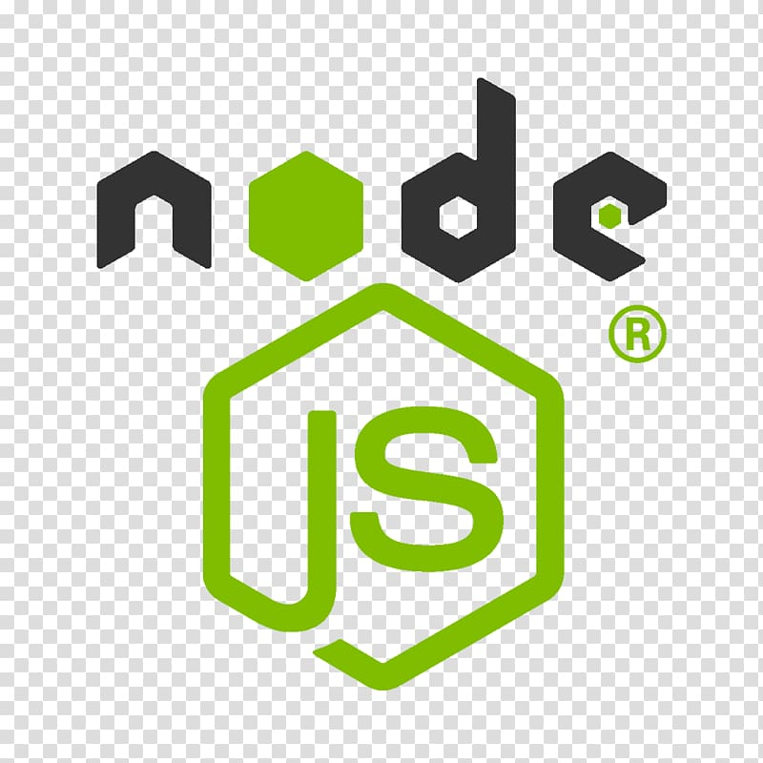

TECHNOLOGIES USED / FRAMEWORK USED

3.1 EXPRESS

Express is a popular web application framework for Node.js, a runtime environment that allows JavaScript code to run outside of a web browser. Express provides a minimalistic and flexible approach to building web applications and APIs. It is known for its simplicity, ease of use, and extensibility.

Express simplifies the process of creating server-side applications by providing a set of robust features and utilities. It allows you to handle HTTP requests, define routes, and create middleware functions to process incoming requests and responses. Express also provides a range of methods for handling different HTTP verbs like GET, POST, PUT, and DELETE.

17

One of the key strengths of Express is its modular nature. It allows you to easily add additional

functionality to your application by using third-party middleware and plugins. This modularity makes it highly customizable and flexible, enabling developers to build applications tailored to their specific needs.

Express also supports template engines, which facilitate the dynamic generation of HTML markup. It provides various template engines such as EJS, Pug, and Handlebars, allowing you to choose the one that suits your preferences.

Overall, Express is widely adopted in the Node.js community due to its simplicity, flexibility, and strong ecosystem. It is an excellent choice for building web applications, RESTful APIs, and backend services in JavaScript.

React is a popular JavaScript library for building user interfaces. It was developed by Facebook and released in 2013. React is widely used for creating interactive web applications and is known for its efficient rendering performance and component-based architecture.

The main concept in React is the component, which represents a reusable and self-contained piece of the user interface. Components can be nested within each other, creating a hierarchical structure. React uses a virtual DOM (Document Object Model) to efficiently update and render the components when there are changes in the application state.

One of the key benefits of React is its declarative approach to building UIs. Instead of directly manipulating the DOM, React allows developers to describe how the UI should look based on the application state, and it takes care of updating the actual DOM efficiently. This makes it easier to manage complex UIs and enables developers to focus on writing reusable and maintainable code.

React also introduces the concept of "props" (short for properties) and "state" to manage data and communication between components. Props are read-only and passed from parent components to child components, while state represents mutable data that belongs to a component and can be updated. By managing data flow through props and state, React ensures a clear and predictable flow of information within the application.

In addition, React has a rich ecosystem with a wide range of libraries and tools, such as React Router for handling routing, Redux for state management, and Material-UI for pre-styled UI components. It also has a vibrant community that actively contributes to the development of React and shares best practices and helpful resources.

Overall, React has gained immense popularity among developers due to its performance, reusability, and community support. It has been widely adopted by many companies and is considered one of the leading libraries for building modern web applications.

18

A CDN, or Content Delivery Network, is a distributed network of servers strategically located around the world to deliver web content efficiently and quickly to users. The primary purpose of a CDN is to reduce latency, enhance website performance, and improve the overall user experience.

When a user requests content from a website, such as images, videos, or static files, the CDN system determines the closest server in its network to the user's location. The content is then cached on that server, allowing subsequent requests for the same content to be served from the nearest server, reducing the distance and time it takes for the content to reach the user.

CDNs utilize various techniques to optimize content delivery. They employ caching mechanisms to store frequently accessed content, minimizing the need to retrieve it from the original source every time. Additionally, CDNs can utilize techniques like data compression, load balancing, and traffic routing to further enhance performance and reliability.

By distributing content across multiple servers worldwide, CDNs can handle high traffic volumes, distribute server load efficiently, and mitigate the effects of localized network congestion or server failures. This improves the availability and resilience of websites, especially during peak usage periods or in geographically dispersed user bases.

CDNs are widely used by websites, streaming services, e-commerce platforms, and other content-driven online businesses to ensure fast and reliable content delivery to their users, regardless of their geographic location. They play a crucial role in optimizing website performance, reducing page load times, and delivering a seamless user experience.

3.2 MONGO DB

MongoDB is a popular open-source NoSQL database management system that provides high performance, scalability, and flexibility for handling large amounts of data. It is designed to store, retrieve, and manage unstructured and semi-structured data in a highly scalable and distributed manner. MongoDB uses a document-oriented data model, which means data is stored in flexible, JSON-like documents that can vary in structure.

Key Features

Document-Oriented Model

19

MongoDB stores data in the form of flexible documents called BSON (Binary JSON). BSON documents are similar to JSON documents, but they include additional data types such as Date, Binary, and more. This document-oriented model allows for dynamic and schema-less data structures, making it easy to evolve your data model as your application requirements change over time.

Scalability and High Performance

MongoDB's architecture is designed to scale horizontally, allowing you to distribute your data across multiple servers and handle high traffic loads. It supports automatic sharding, which partitions data across multiple machines, and ensures that read and write operations are evenly distributed for optimal performance.

Replication and High Availability

MongoDB provides built-in replication functionality, allowing you to create replicas of your data across multiple servers. Replication provides redundancy and high availability, ensuring that your data remains accessible even in the event of hardware failures or network issues. In case of a primary server failure, MongoDB automatically promotes one of the replicas to become the new primary.

Rich Query Language

MongoDB supports a powerful query language that allows you to perform complex queries on your data. The query language supports a wide range of operators, including comparison, logical, and geospatial operators, among others. It also provides support for full-text search, making it easy to search for text within your documents.

Flexible Indexing

MongoDB supports various indexing techniques to optimize query performance. You can create indexes on individual fields, compound indexes on multiple fields, and even create indexes on arrays and sub-documents. Indexes significantly improve query execution time by allowing MongoDB to quickly locate and retrieve the requested data.

20

Aggregation Framework

MongoDB's Aggregation Framework provides a powerful set of tools for performing data processing tasks such as filtering, grouping, sorting, and transforming data. It allows you to build complex queries and perform advanced analytics on your data without the need for external tools or frameworks.

Integration with Programming Languages

MongoDB provides official drivers for a wide range of programming languages, including Python, Java, Node.js, and many more. These drivers offer a convenient and consistent interface for interacting with MongoDB from your application code. Additionally, MongoDB supports a native JavaScript shell that allows you to interact with the database using JavaScript commands.

Community and Ecosystem

MongoDB has a vibrant and active community, which means there are numerous online resources, forums, and user groups available to help you with any questions or issues you may encounter. The ecosystem around MongoDB is also rich, with a wide variety of third-party tools and libraries available for different use cases, such as data visualization, data migration, and more.

Conclusion

MongoDB is a versatile and powerful NoSQL database management system that offers scalability, performance, and flexibility for handling modern application data needs. Its document-oriented model, distributed architecture, and rich feature set make it an excellent choice for a wide range of projects. Whether you're building a small-scale application or a large-scale distributed system, MongoDB provides the tools and capabilities to manage your data effectively.

21

3.3 BUNDLERS

Bundler



A bundler for a project file is a tool that facilitates the process of packaging and organizing the various assets, dependencies, and code files required for a software project. It simplifies the deployment and distribution of applications by bundling all the necessary resources into a single file or set of files that can be easily deployed to a target environment.

Bundlers play a crucial role in modern web development, where projects often involve numerous JavaScript, CSS, and image files that need to be loaded and served efficiently. They help manage dependencies, optimize code, and improve performance by reducing the number of requests made to the server and minimizing file sizes.

One popular bundler is webpack. Webpack is a powerful module bundler that can handle a wide range of assets, including JavaScript modules, CSS stylesheets, images, fonts, and more. It analyzes the project's dependency graph to determine which files are needed and generates a bundle that can be included in a web page.

Webpack offers various features to optimize the bundled output, such as code minification, tree shaking (eliminating unused code), and chunk splitting (separating code into smaller files to be loaded on-demand). It also supports a plugin system that allows developers to extend its functionality to suit their specific project requirements.

Another well-known bundler is Parcel. Parcel is a zero-configuration bundler that simplifies the setup process for developers. It automatically detects and resolves dependencies, supports various file types out of the box, and provides built-in development server and hot module replacement for seamless development experience. Parcel focuses on simplicity and performance, making it an attractive choice for small to medium-sized projects.

22

CHAPTER 4: SYSTEM DESIGN

4.1 OVERVIEW:

The Config-based UI Project File system is designed to provide a flexible and customizable user interface for projects. It allows users to define the layout, appearance, and behavior of the UI elements using configuration files. This system design outlines the key components and their interactions.

User Interface:

The user interface is the primary component of the system, responsible for rendering UI elements and handling user interactions. It consists of various UI components like buttons, forms, tables, etc. The UI components will be dynamically generated based on the configuration files.

Configuration Files:

The configuration files define the structure, appearance, and behavior of the UI components. These files are typically written in a structured format such as JSON or YAML. The configuration files should include the following sections:

Layout Configuration: Defines the overall structure of the UI, including the placement and sizing of UI components.

Appearance Configuration: Specifies the visual styling of the UI components, such as colors, fonts, and images.

Behavior Configuration: Describes the behavior of the UI components, including event handling, validation rules, and data binding.

Configuration Parser:

The configuration parser is responsible for reading and parsing the configuration files. It interprets the configuration data and generates an internal representation of the UI structure, appearance, and behavior. The parser should handle various configuration formats and provide error handling for invalid or missing data.

23

UI Renderer:

The UI renderer takes the internal representation of the UI generated by the configuration parser and renders it on the screen. It uses a rendering engine or library to display the UI components according to the specified layout and appearance. The renderer should be capable of handling dynamic updates to the UI based on changes in the configuration files.

Event Handling:

The UI components may have interactive behavior, such as button clicks or form submissions. The system should provide event handling mechanisms to capture and process user interactions. Events triggered by the UI components should be mapped to corresponding actions defined in the configuration files.

Data Binding:

The UI components may need to display or manipulate data from external sources, such as a database or API. The system should support data binding, allowing the UI components to dynamically update their content based on changes in the underlying data. The data binding mechanism should be configurable in the configuration files.

Persistence:

The system should provide a mechanism to save and load the configuration files. This allows users to store their UI configurations and retrieve them later. The persistence mechanism could use a file system, database, or any other suitable storage solution.

Security:

To ensure the security of the project files, the system should implement appropriate access controls and encryption mechanisms. Users should have the necessary permissions to create, modify, and access project files. Encryption can be used to protect sensitive information stored in the configuration files.

Conclusion:

The Config-based UI Project File system provides a flexible and customizable approach to designing user interfaces. It allows users to define the structure, appearance, and behavior of UI components using configuration files. By separating the UI configuration from the underlying code, the system enables easier maintenance, updates, and customization of the user interface.

24

4.2 DEMO API

**{**

**"statusCode": 0,**

**"data": {**

**"cacheExpiryTime": 320,**

**"pages": 1,**

**"pageIndex": 0,**

**"scrubber": 0,**

**"configs": {**

**"ribbons": {**

**"PREORDER": {7 items},**

**"EXCLUSIVE": {7 items},**

**"NEW": {7 items},**

**"REPEAT": {7 items},**

**"CLOUD": {7 items},**

**"PREMIUM": {7 items},**

**"PROMOTED": {7 items}**

**},**

**"croutons": {2 items}**

**},**

**"totalSize": 211,**

**"currentOffset": 15,**

**"cards": [16 items],**

**"nextPageFetch": 0**

**},**

**"tid": "ea04e434-6a8b-4ee8-ac30-8cef578590de",**

**"sid": "7g695a96-d9e9-40d5-bd9c-50dfbf28a494",**

**"deviceId": "d0f455ea-39c6-0ab7-9d0c-6c002233b3d0",**

**"csrfToken": "TFipYi1I8u5S-lHitiNUytOy6FnHDgPL_94t85AE"**

**}**

25

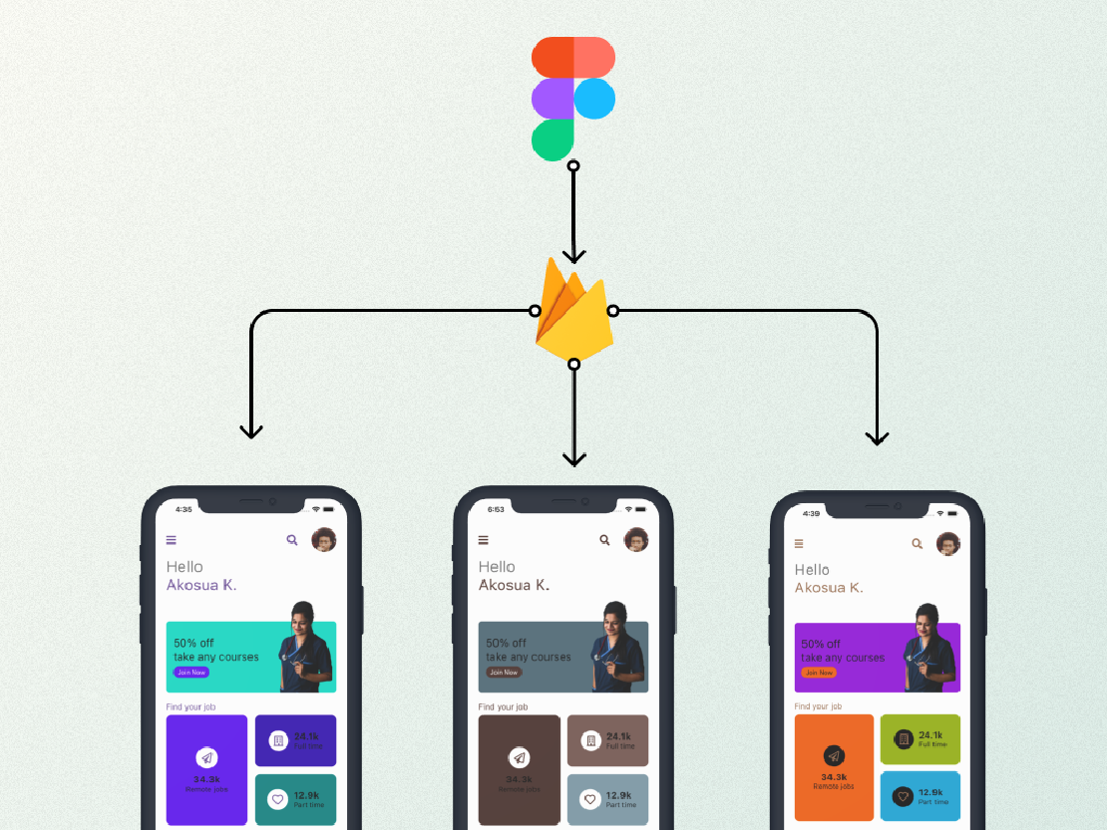

CONFIG UI

26

CHAPTER 5: SYSTEM IMPLEMENTATION AND TESTING

5.1 IMPLEMENTATION

In modern web development, building robust and efficient APIs is crucial for creating scalable applications. Express, a popular Node.js web framework, provides a powerful foundation for developing APIs due to its simplicity and flexibility. This document outlines the theory and implementation details of utilizing Express to build an API for a project file.

Setting Up the Project:

To begin, ensure that Node.js and npm (Node Package Manager) are installed on your system. Create a new directory for the project, navigate to it using the command line, and initialize a new npm package by running npm init. Follow the prompts to set up the project's package.json file.

5.2 CONFIG API IMPLEMENTATION

Express can be installed via npm by running npm install express. This command will download Express and its dependencies, adding them to the project's node_modules folder.

Creating the Express App:

Create a new JavaScript file, such as app.js, and import the Express module at the top of the file using const express = require('express');. Then, create an instance of the Express application by invoking express() and assign it to a variable, typically called app.

Handling Routes:

Express uses routing to handle different HTTP methods (GET, POST, PUT, DELETE) and URLs. Define routes for your API endpoints using the app.<HTTP_METHOD>(url, handler) syntax. For example, app.get('/api/projects', (req, res) => { ... }) handles GET requests to the /api/projects endpoint.

27

Implementing Route Handlers:

Inside the route handlers, you can define the logic to process the incoming requests and send

appropriate responses. Access request parameters, query strings, headers, and payloads using the req object. To send a response, utilize the res object, such as res.send() or res.json().

Middleware:

Express middleware functions can intercept and modify requests and responses. Implement middleware to perform tasks such as authentication, logging, error handling, or data validation. Use app.use() to apply middleware globally or to specific routes.

Error Handling:

To handle errors, create a middleware function with four parameters: (err, req, res, next). If an error occurs in a route handler or middleware, invoke next(err) to pass the error to the next error-handling middleware or the default Express error handler.

CORS Configuration:

If your API serves requests from a different origin (domain), configure Cross-Origin Resource Sharing (CORS) to allow or restrict access to your API from specific domains. The cors middleware package can be used for this purpose.

Environmental Configuration:

Consider utilizing environment variables to configure sensitive information (e.g., database connection details, API keys) and other settings for different environments (development, production). The dotenv package can be used to load environment variables from a .env file.

Testing the API:

Use testing frameworks like Mocha, Jest, or Postman to verify the functionality of your API routes and middleware. Write tests to cover different scenarios and ensure your API behaves as expected.

28

Conclusion:

By following the theory and implementation details discussed above, you can utilize Express to build a powerful and efficient API for your project file. Express provides a flexible foundation for handling routes, implementing middleware, managing errors, and configuring environmental variables, enabling you to create a scalable and robust API.

5.3 REACT IMPLEMENTATION

In a React project, the implementation details for painting the browser based on config API data typically involve the following steps:

Setup: Begin by setting up your React project with the necessary dependencies, such as React, ReactDOM, and any additional libraries or packages required for your specific needs.

Component Hierarchy: Design your component hierarchy based on the structure and layout of your application. Break down your user interface into reusable components that can be composed together to form the desired layout.

Config API Data: Retrieve the necessary configuration data from the API. This data could include information about colors, styles, layout options, or any other relevant details that determine how the browser should be painted.

State Management: Create a state management system using React's built-in state management, such as the useState or useReducer hooks, or by employing external libraries like Redux or MobX. This state management system will be used to store and update the configuration data retrieved from the API.

API Integration: Integrate the API into your React application by making asynchronous calls to fetch the config data. This can be achieved using libraries like Axios or the native Fetch API. Upon receiving the data, update the state management system with the retrieved values.

Component Rendering: Create React components responsible for rendering different parts of the browser based on the config data. These components should receive the relevant configuration values as props and use them to determine their appearance.

29

Conditional Styling: Utilize the config data within your component rendering logic to conditionally apply styles and classes. For example, you can conditionally apply different background colors, font sizes, or positioning based on the retrieved configuration values.

Event Handling: Implement event handlers within your components to allow user interactions that can modify the configuration data. For instance, you might include buttons or input fields that enable users to change the browser's appearance dynamically.

Reconciliation and Virtual DOM: Leverage React's reconciliation algorithm and virtual DOM to efficiently update the browser's display. React will determine the minimal set of changes needed to reflect the updated configuration data and efficiently apply those changes to the actual DOM.

Render to Browser: Finally, use ReactDOM to render your React component hierarchy to the browser. The updated appearance, based on the retrieved config data and user interactions, will be painted in the browser based on the changes determined by React's reconciliation process.

By following these implementation details, you can effectively leverage React's declarative and efficient rendering to paint the browser based on the config API data in your project file.

5.4 SHIMMER LAYOUT IMPLEMENTATION

The implementation of a shimmer layout involves utilizing the configuration API data to create a visually appealing effect that simulates content loading or placeholders. This effect is commonly used in web and mobile applications to provide users with visual feedback while waiting for actual content to load. To implement a shimmer layout, the following steps can be taken:

Retrieve Config API Data: Begin by fetching the necessary configuration data from the API. This data should include details about the structure and styling of the shimmer layout, such as the number of shimmer elements, their dimensions, positioning, and animation properties.

30

Create Shimmer Elements: Using the retrieved configuration data, dynamically generate HTML elements that will represent the shimmer effect. These elements could be simple divs or any other suitable container. Set their dimensions, positioning, and styling based on the provided information.

Apply Shimmer Animation: To create the shimmer effect, apply a CSS animation to the generated shimmer elements. This animation typically consists of a repeating gradient or pattern that moves horizontally across the elements. This movement gives the illusion of shimmering or loading content.

Insert Shimmer Elements: Place the generated shimmer elements within the appropriate sections of the project file where content is expected to be loaded. This can be done by manipulating the DOM or using a templating system if applicable.

Handle Content Loading: While the actual content is being loaded asynchronously, the shimmer layout should remain visible to the user. Ensure that the content loading process occurs separately from the shimmer animation to prevent any interference.

Replace Shimmer with Content: Once the content is loaded successfully, remove or hide the shimmer elements and replace them with the actual content. Adjust the layout as necessary to accommodate the loaded content.

Error Handling: Implement appropriate error handling mechanisms to handle cases where content retrieval fails. In such scenarios, display an error message or fallback content instead of the shimmer layout.

By following these steps, you can create a shimmer layout implementation that utilizes the provided configuration data to paint the browser with a visually appealing effect. This approach ensures a smooth user experience by providing visual feedback during content loading, enhancing perceived performance, and reducing user frustration.

31

CHAPTER 6: IMPLEMENTATION OF THE MODULES

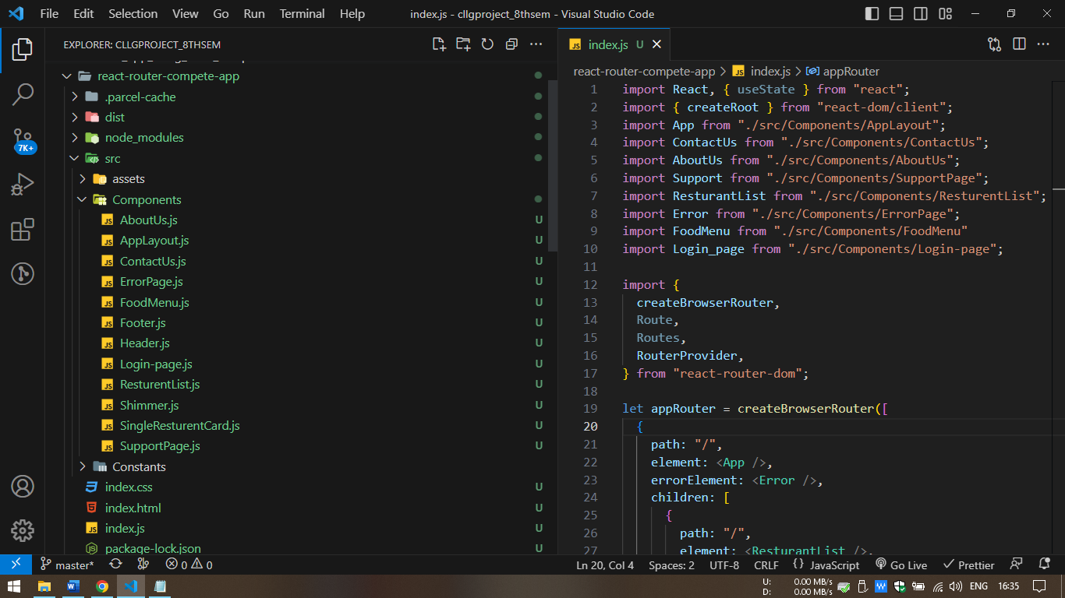

File Structure

6.1 REACT JS PART

React Hooks provide a way to use state and other React features in functional components. When working with React Hooks in a project file, you can follow this theory:

Understanding React Hooks:

Familiarize yourself with the concept and purpose of React Hooks. Understand how they enable you to use state, lifecycle methods, and other features in functional components. Gain knowledge about the different types of hooks provided by React, such as useState, useEffect, useContext, etc.

Identifying Components:

Identify the functional components in your project file where you want to introduce hooks. Consider components that could benefit from managing state, handling side effects, or accessing context. Assess which hooks are most suitable for each component based on their requirements.

32

Importing React and Required Hooks:

Import React and the necessary hooks you plan to use. Typically, you import React at the top of your file, and hooks are imported individually based on your component's needs.

Applying useState Hook:

Determine if any components require state management. Use the useState hook to declare state variables within the component. This hook provides a state variable and a function to update that variable. Update the state using the provided function to ensure proper rendering.

Using useEffect Hook:

Identify components that need to perform side effects, such as fetching data, subscribing to events, or manipulating the DOM. Utilize the useEffect hook to handle these side effects. Write the necessary code within the effect function and specify the dependencies, if any, that should trigger the effect.

Leveraging Other Hooks:

Determine if your components need other hooks, such as useContext for accessing context, useRef for storing mutable values, or useReducer for managing complex state transitions. Import and use these hooks in your components as needed, following the respective documentation and guidelines for each hook.

Testing and Refactoring:

Test your components and hooks to ensure they function correctly. Write unit tests that cover different scenarios, edge cases, and component interactions. Refactor your code as needed to improve readability, maintainability, and performance.

Optimizing with useMemo and useCallback:

Consider using the useMemo and useCallback hooks to optimize performance in components that rely on expensive computations or callbacks. These hooks help memoize values and functions, preventing unnecessary re-evaluations and re-renders.

33

Monitoring with React DevTools:

Utilize React DevTools, a browser extension or integrated tool, to inspect and debug your components and hooks. It provides valuable insights into the component hierarchy, state changes, and performance profiles, aiding in the optimization and troubleshooting process.

Keeping Up with React Documentation and Best Practices:

Stay updated with the React documentation, guidelines, and best practices related to hooks. React's official website offers comprehensive resources and examples to assist you in effectively utilizing hooks and staying current with any updates or changes.

By following this theory, you can effectively incorporate React Hooks into your project file, enabling you to write functional components with state management, side effect handling, and other React features.

**useEffect(()=>{**

**console.log("use effect called")**

**fetch(API_URL2)**

**.then((response) => response.json())**

**.then((recivedData) => {**

**console.log(recivedData.data.cards)**

**setapiData(recivedData.data.cards)**

**setFilteredData(recivedData.data.cards)**

**})**

**.catch((error) => console.error(error));**

**},[])**

API call is done in this way.

6.2 API DEVELOPMENT

To develop an Express API for a project file, you can follow a theory that involves several key steps. Here's a general outline of the process:

34

Project Setup and Dependencies:

Set up your project directory and initialize a new Node.js project. Install the necessary dependencies, including Express, using a package manager like npm or Yarn.

Create an Express Application:

Create an instance of the Express application using the express() function. This sets up the foundation for building your API.

Routing and Endpoints:

Define routes and endpoints for your API. Use the Express Router to group related routes together. Define the HTTP methods (GET, POST, PUT, DELETE, etc.) and corresponding handlers for each endpoint. The handlers can be functions or middleware that handle incoming requests and produce appropriate responses.

Request Handling:

Access request data using middleware or the request object's properties (e.g., req.params, req.query, req.body). Validate and sanitize input data to ensure its integrity. Perform necessary operations, such as reading or modifying files, interacting with databases, or making external API calls.

Response Generation:

Generate appropriate responses based on the received requests. Set response headers, status codes, and content types. Format the response payload, which can be in JSON, HTML, XML, or any other desired format. Return the response to the client.

Error Handling:

Implement error handling mechanisms to handle exceptions and unexpected scenarios. Use middleware or custom error handlers to catch errors, log them, and provide meaningful error messages to clients. Consider using status codes that accurately represent the nature of the error (e.g., 400 for bad requests, 500 for internal server errors).

35

Middleware and Additional Functionality:

Utilize middleware functions to add additional functionality to your API, such as authentication, request logging, rate limiting, or CORS handling. Apply middleware to specific routes or globally to the entire application as per your requirements.

Testing and Validation:

Write automated tests using testing frameworks like Mocha, Chai, or Jest to ensure the correctness and stability of your API. Test different scenarios, handle edge cases, and validate the behavior of your endpoints. Use tools like Postman or cURL to manually test your API and verify its functionality.

Documentation and API Design:

Document your API using tools like Swagger, OpenAPI, or API Blueprint. Describe the available endpoints, their input/output formats, and any required authentication or authorization mechanisms. Consider adhering to RESTful API design principles or other relevant design patterns.

Deployment and Scaling:

Prepare your API for deployment to a production environment. Consider containerization with Docker or using a cloud platform like Heroku, AWS, or Google Cloud. Implement proper scaling strategies to handle increased traffic and load, such as load balancing or horizontal scaling.

Remember that this theory provides a general guideline for developing an Express API, and the specific implementation may vary based on the requirements and complexity of your project. Adapt and refine these steps to fit your project's needs and best practices.

36

const express = require('express');

const https = require('https');

const app = express();

const port = 3000;

const { ApiData } = require('./constants.js');

app.get('/config/api', (req, res) => {

res.send(ApiData)

});

app.listen(port, () => {

console.log(`Server is running on port ${port}`);

});

37

CHAPTER 7: TESTING

Jest



When it comes to testing a project, file based on Config-driven UI and React, there are a few key aspects to consider. Here's a general outline of a testing theory that you can adapt to your specific project:

Understanding the Project Structure and Dependencies:

Familiarize yourself with the project's architecture, directory structure, and dependencies. This will help you identify the areas of the codebase that require testing and understand how different components and configurations interact.

Unit Testing:

Start by writing unit tests for individual functions, components, and modules. Since React is component-based, focus on testing the functionality of each component and its behavior with different configurations. Utilize testing frameworks like Jest along with libraries like React Testing Library or Enzyme to assist you in writing and running these tests.

Integration Testing:

Test the integration between different components and their interactions with the configuration files. This can involve simulating user interactions and verifying that the UI renders correctly based on the given configuration. Consider using tools like Cypress or Selenium for UI automation testing, as they allow you to interact with the application and validate its behaviour.

38

Configuration Testing:

Since the UI is driven by configuration files, it's essential to test the different configurations to ensure they produce the expected results. Write tests that cover various scenarios and edge cases based on the configurations available in the project file. Consider using test data generation techniques or tools to generate a wide range of test cases efficiently.

Snapshot Testing:

Utilize snapshot testing to capture and validate the rendered output of components against a known baseline. React testing frameworks often provide snapshot testing capabilities, allowing you to compare the current render output with a previously saved snapshot. This helps detect unexpected UI changes introduced during development.

Performance Testing:

Assess the performance of your application by conducting performance tests. Identify critical areas that might affect user experience, such as loading times or rendering efficiency, and measure their performance using tools like Lighthouse, Webpage Test, or Chrome Retools. Monitor and optimize the application's performance by eliminating bottlenecks.

Continuous Integration and Deployment (CI/CD) Testing:

Set up automated testing as part of your CI/CD pipeline to ensure that every code change goes through a series of tests before being deployed. Include all relevant tests, such as unit tests, integration tests, and configuration tests, to validate the code changes and configurations in a consistent and reliable manner.

Remember, this testing theory is a general guideline, and the specific testing needs may vary depending on your project's requirements. It's essential to adapt and refine your testing approach based on the characteristics of your project and the specific challenges you encounter along the way.

When testing a React app, there are several popular tools and libraries available that can assist you in writing tests effectively. Here are some commonly used tools for testing React applications:

39

Jest: Jest is a powerful JavaScript testing framework that provides a robust and easy-to-use testing solution for React apps. It supports snapshot testing, mocking, and assertions out of the box, making it a popular choice for testing React components and utilities.

React Testing Library: React Testing Library is a testing utility specifically designed for testing React components. It encourages testing components in a way that closely resembles how a user would interact with the application. React Testing Library provides simple and intuitive APIs to interact with and assert on rendered components.

Enzyme: Enzyme is another popular testing utility for React that provides a set of powerful APIs for testing React components. It offers shallow rendering, which allows testing components in isolation without deeply rendering child components. Enzyme also provides a convenient syntax for querying and manipulating component output.

Testing Frameworks: Testing frameworks like Mocha, Jasmine, or Ava can be used in conjunction with React testing tools to organize and execute tests. They provide a test runner and assertion libraries to structure and validate your tests.

React Test Renderer: React Test Renderer is a package included with React that allows you to render React components to a plain JavaScript object. It's useful for snapshot testing or testing components without the need for a full DOM or browser environment.

Cypress: Cypress is an end-to-end testing framework that allows you to write tests that simulate user interactions and behavior. It provides a robust API to interact with your React app and can be used for UI testing, integration testing, and even visual regression testing.

Mocking Libraries: Libraries like Sinon.js or Jest's built-in mocking features can help you mock dependencies or simulate different scenarios during testing. Mocking is useful when you want to isolate components or test interactions with external services or APIs.

Code Coverage Tools: Tools like Istanbul or Jest's built-in coverage reports can help you measure the code coverage of your tests. They provide insights into which parts of your codebase are covered by tests and help identify areas that need additional testing.

40

CHAPTER 8: SCREENSHOTS

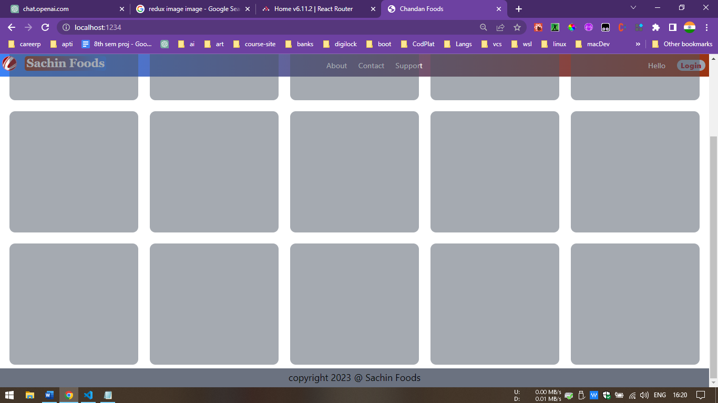

Started Loading Shimmer

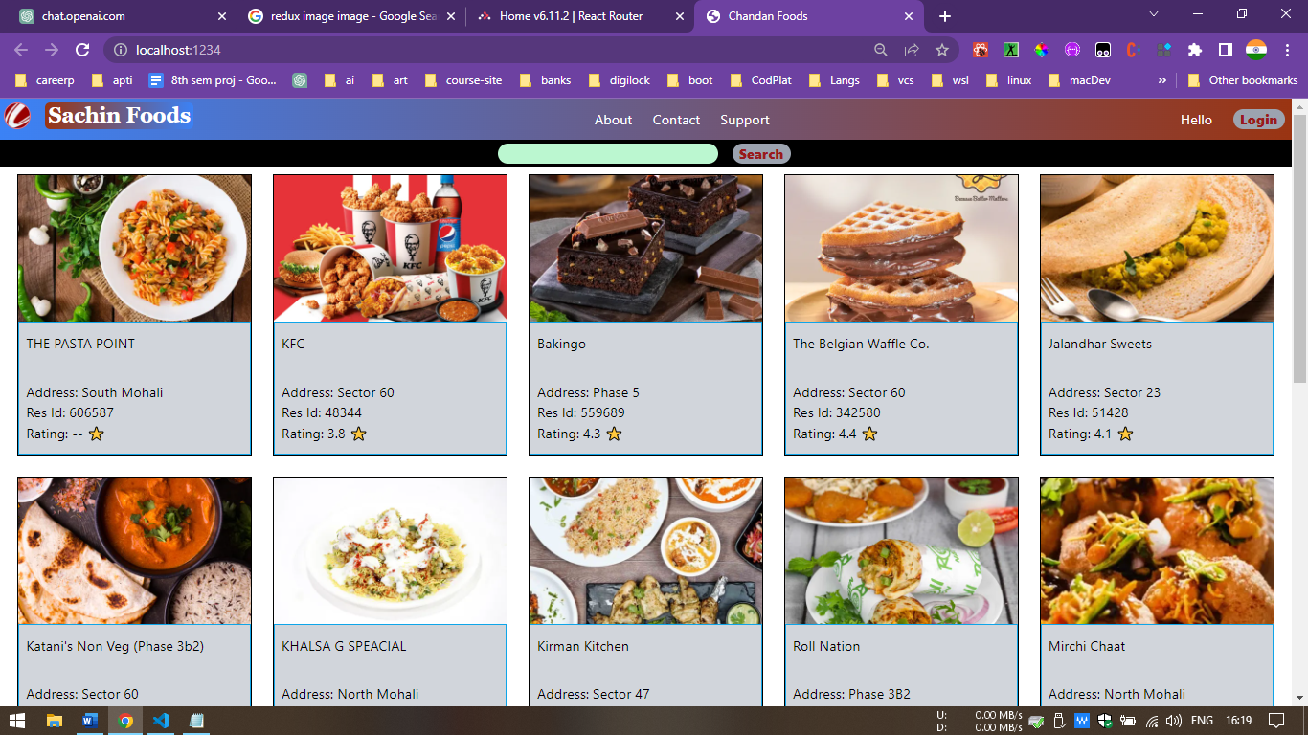

41

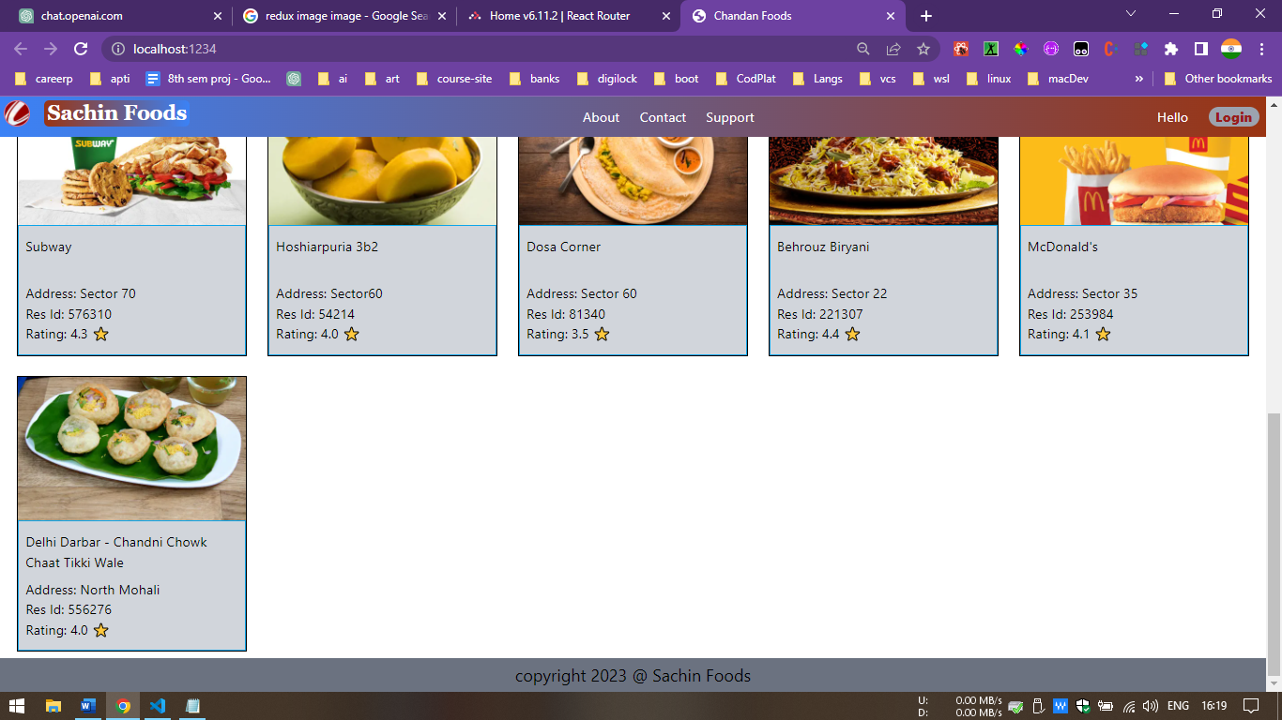

Painted After Receiving Config API

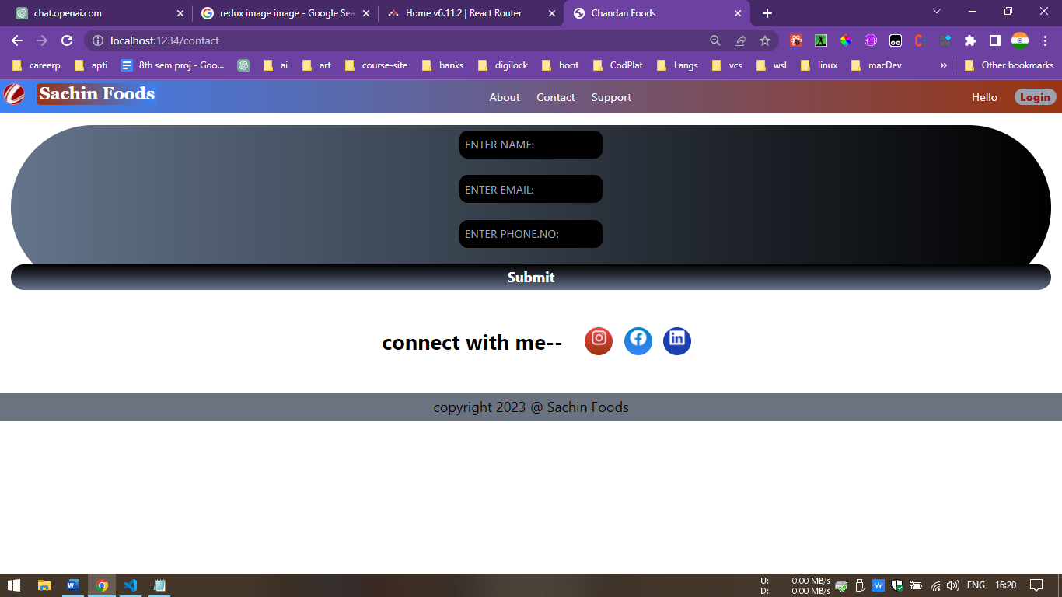

Contact Page

42

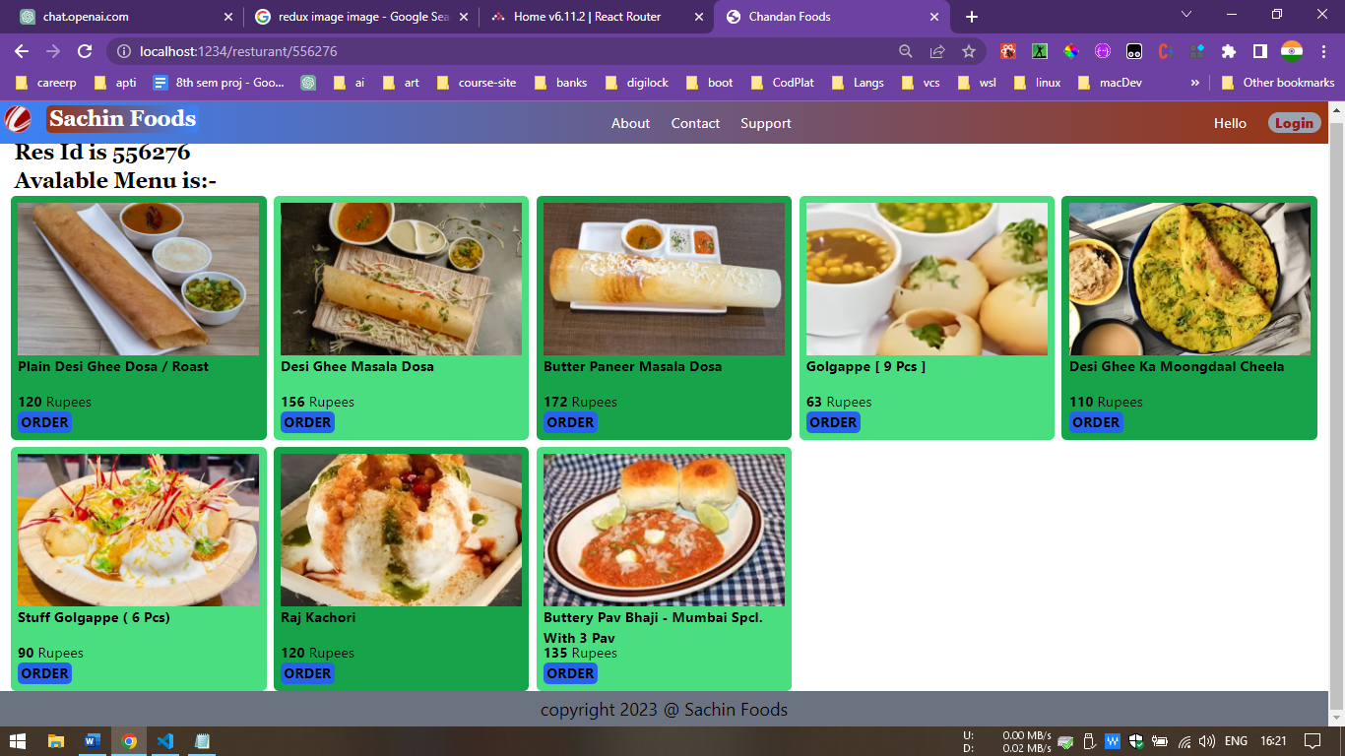

A Single Restaurant Menu

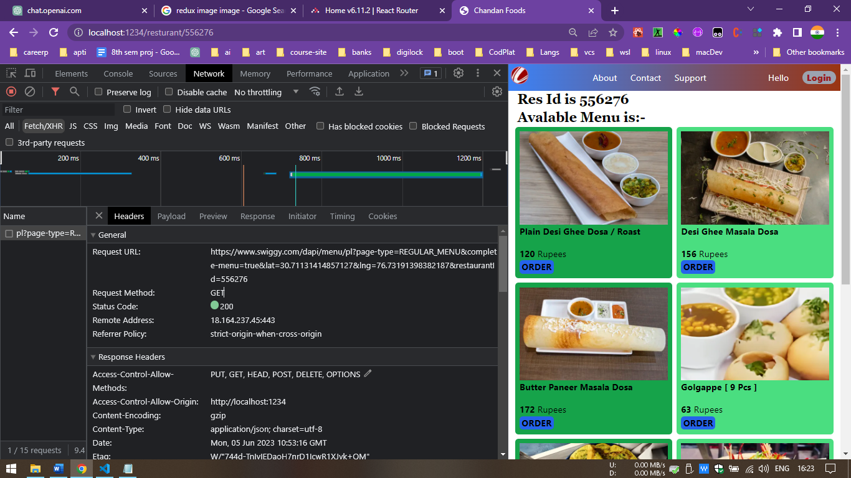

Https Request Header

43

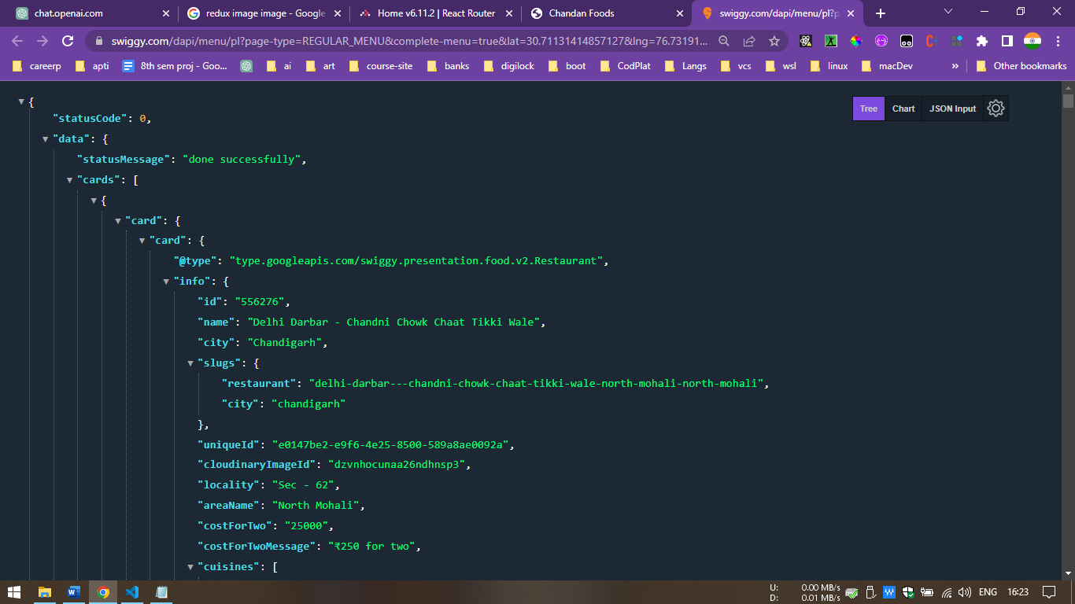

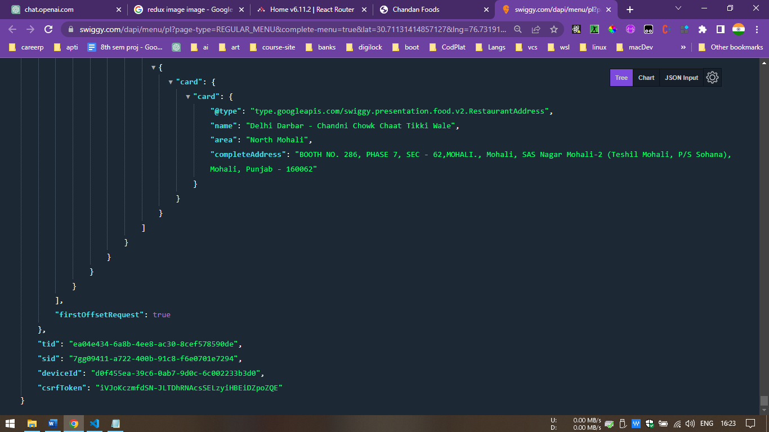

Config API

44

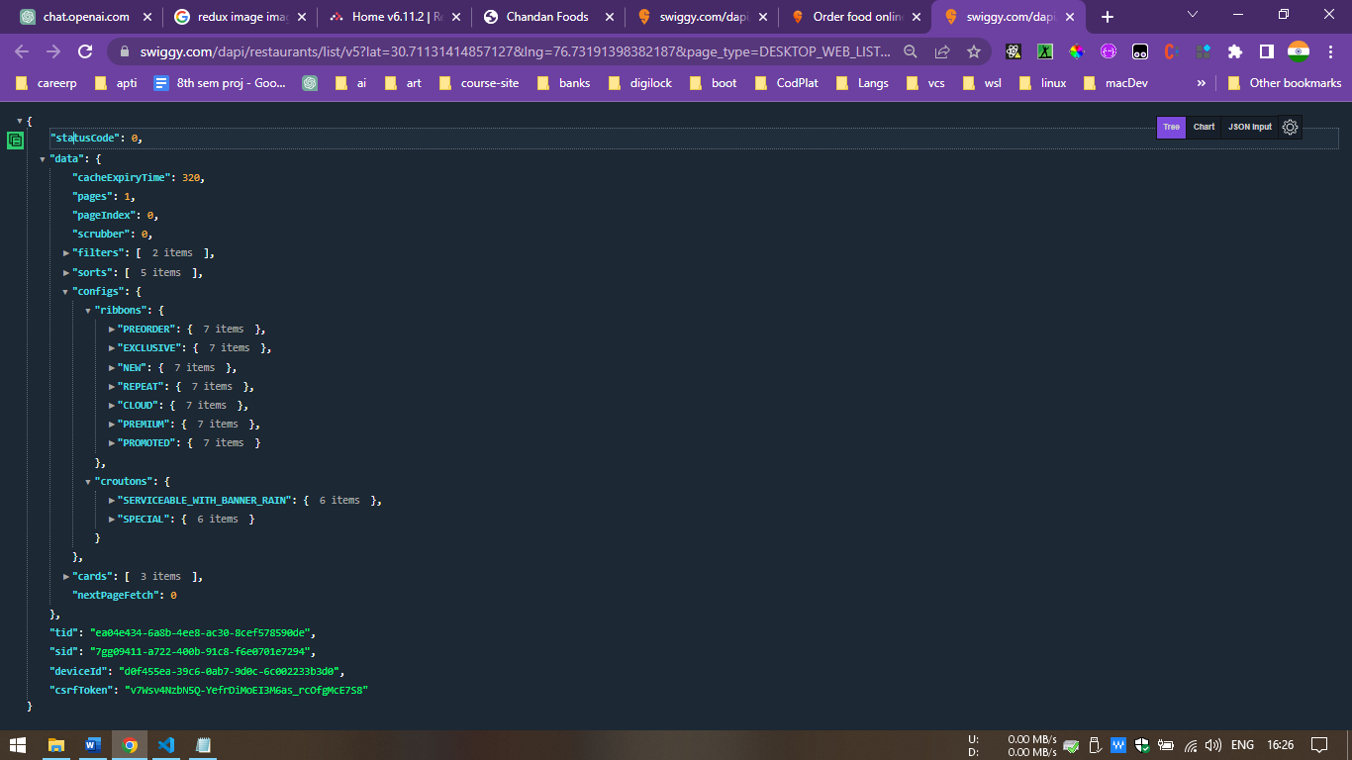

Config API Keys

45

CHAPTER 9: CONCLUSIONS & FUTURE SCOPE

9.1 CONCLUSION

In conclusion, the configuration-based UI project has been a significant undertaking that has provided valuable insights and outcomes. Throughout this project, we have explored the concept of a configuration-driven user interface, which offers flexibility and adaptability to meet various user requirements. By leveraging configuration files, we have effectively separated the presentation layer from the business logic, enabling easy customization and maintenance.

During the project, we successfully implemented a robust framework that interprets configuration files and dynamically generates user interfaces based on the provided specifications. This approach has allowed us to create UI components on-the-fly, reducing the development time and enhancing scalability. By decoupling the UI from the underlying logic, we have empowered non-technical users to make modifications without extensive coding knowledge.

Moreover, the configuration-based UI project has demonstrated its ability to streamline the development process. With a centralized configuration file, we can quickly prototype, iterate, and update the UI without affecting the core functionality. This agility has proven especially beneficial in situations where UI changes are frequent or where multiple variants of an application need to be created.

Furthermore, the project has provided several advantages, including improved code maintainability, enhanced reusability of UI components, and easier collaboration among development teams. By adopting a configuration-driven approach, we have also future-proofed our application, as changes can be seamlessly introduced without requiring extensive code refactoring.

However, it is essential to acknowledge that there were challenges encountered along the way. Creating a flexible configuration system that covers a wide range of UI requirements and edge cases required careful consideration and thorough testing. Additionally, ensuring the security and integrity of the configuration files was of utmost importance to prevent unauthorized modifications.

46

In conclusion, the configuration-based UI project has revolutionized our development process by introducing a highly adaptable and customizable approach to building user interfaces. The benefits of this project extend beyond the initial implementation, offering long-term advantages in terms of development speed, maintainability, and scalability. By embracing this innovative approach, we have positioned ourselves at the forefront of UI development, ready to meet the evolving needs of our users and stay ahead in a rapidly changing technological landscape.

9.2 FUTURE SCOPE

Config-based UI projects have gained significant popularity in recent years due to their flexibility, scalability, and ease of maintenance. These projects rely on configuration files to define the UI components, layouts, and behavior, making it easier for developers and designers to collaborate and iterate. As technology continues to advance, there are several exciting future scopes for config-based UI projects. This article explores some of these potential areas of development and improvement.

Enhanced Configuration Options:

One of the key areas for future improvement in config-based UI projects is the expansion of configuration options. This includes providing more granular control over UI components, such as styling, animations, and interaction behaviors. By allowing developers to fine-tune these aspects through configuration files, the project can accommodate a wider range of design requirements, resulting in more unique and tailored user experiences.

Integration with Design Tools:

Integrating config-based UI projects with popular design tools, such as Figma or Sketch, can streamline the design-to-development workflow. This integration can enable designers to export their designs directly into the configuration format, reducing manual effort and ensuring visual fidelity. Additionally, designers can collaborate more effectively with developers by providing annotations, interactions, and design specifications within the design tool itself, which can be easily translated into the project's configuration file.

Live Preview and Rapid Prototyping:

A significant future scope for config-based UI projects lies in the development of live preview

47

and rapid prototyping capabilities. By integrating real-time preview functionality into the development environment, developers can see instant changes to the UI based on configuration updates. This allows for faster iteration and more efficient prototyping, leading to reduced development time and enhanced user feedback.

Internationalization and Localization Support:

Config-based UI projects can greatly benefit from built-in internationalization (i18n) and localization (l10n) support. Providing configuration options for language-specific text, date formats, and cultural adaptations can help create applications that are easily localized for different regions and languages. This future scope can significantly expand the reach and usability of config-based UI projects on a global scale.

Component Libraries and Community Contributions:

Establishing component libraries and fostering a vibrant community around config-based UI projects can contribute to their growth and success. A centralized repository of reusable UI components, templates, and configurations can enable developers to share and collaborate more effectively. This future scope allows for greater efficiency, standardization, and promotes knowledge sharing within the community.

Accessibility and Usability:

The future of config-based UI projects should prioritize accessibility and usability enhancements. Providing configuration options that promote accessibility best practices, such as color contrast ratios, keyboard navigation, and screen reader compatibility, can make applications more inclusive and user-friendly. Moreover, integrating automated accessibility testing tools into the development workflow can help identify and rectify accessibility issues early in the development process.

48

CHAPTER 10: REFERENCES / BIBLIOGRAPHY

Web Links and Books:

"Design Systems: Configurable UIs" by Nathan Curtis: https://medium.com/eightshapes-llc/design-systems-configurable-uis-723a2af7598d

This article discusses the concept of configurable UIs within the context of design systems and provides practical insights and considerations.

"Building a Configurable UI Component System" by Sarah Drasner: https://css-tricks.com/building-a-configurable-ui-component-system/

This tutorial demonstrates how to build a configurable UI component system using React and CSS variables.

"The Case for Configuration-Driven User Interfaces" by Karthik Viswanathan: https://www.smashingmagazine.com/2019/08/configuration-driven-user-interfaces/

This article explores the benefits and considerations of configuration-driven user interfaces and provides real-world examples.

React Documentation: https://reactjs.org/docs/getting-started.html

The official documentation for React provides a comprehensive guide to getting started with React, understanding its core concepts, and exploring various features and APIs.

React Tutorial by React Team: https://reactjs.org/tutorial/tutorial.html

This interactive tutorial walks you through building a tic-tac-toe game using React, helping you understand the fundamentals of React component-based development.

React Router Documentation: https://reactrouter.com/

React Router is a popular library for handling routing in React applications. The documentation provides a guide to setting up routing in your app and utilizing its features.

Redux Documentation: https://redux.js.org/

Redux is a predictable state container for JavaScript apps, often used with React. The documentation offers a thorough explanation of Redux concepts, usage, and integration with React.

React Bootstrap Documentation: https://react-bootstrap.github.io/

React Bootstrap is a library that brings Bootstrap components to React applications. The documentation provides guidance on using Bootstrap components in React.Books:

"Design Systems: A Practical Guide to Creating Design Language for Digital Products" by Alla Kholmatova

This book covers various aspects of design systems, including the creation of configurable UI components and the role of configuration in maintaining consistency.

"Atomic Design" by Brad Frost

49

While not explicitly focused on configuration-based UIs, this book explores the principles of modular UI design, which can be applied to the development of configurable UIs.

"React Design Patterns and Best Practices" by Michele Bertoli

This book discusses different design patterns and best practices in React development, including the creation of reusable and configurable UI components.

"Learning React: Modern Patterns for Developing React Apps" by Alex Banks and Eve Porcello

This book offers a comprehensive introduction to React, covering fundamental concepts, state management, component composition, and building real-world applications.

"Pro React" by Cassio de Sousa Antonio, Vasan Subramanian, and Nate Murray

This book dives into advanced topics and best practices for React development, including testing, performance optimization, and integrating React with other technologies.

"React Up and Running: Building Web Applications" by Stoyan Stefanov

This book provides a hands-on approach to learning React, covering the basics, component lifecycle, state management, and practical examples.

"Fullstack React: The Complete Guide to ReactJS and Friends" by Anthony Accomazzo, Ari Lerner, Nate Murray, and David Guttman

This comprehensive guide covers React, React Router, Redux, and server-side rendering, providing a full-stack perspective on React development.

50